**Project Design Phase-II**

**Data Flow Diagram & User Stories**

|  |  |
| --- | --- |
| Date | 15 April 2025 |
| Team ID | SWTID1743870576 |
| Project Name | SpendSmart: Your Personal Finance Companion |
| Maximum Marks | 4 Marks |

**Data Flow Diagrams:**

A Data Flow Diagram (DFD) is a traditional visual representation of the information flows within a system. A neat and clear DFD can depict the right amount of the system requirement graphically. It shows how data enters and leaves the system, what changes the information, and where data is stored.

**Example:** [**(Simplified)**](https://developer.ibm.com/patterns/visualize-unstructured-text/)

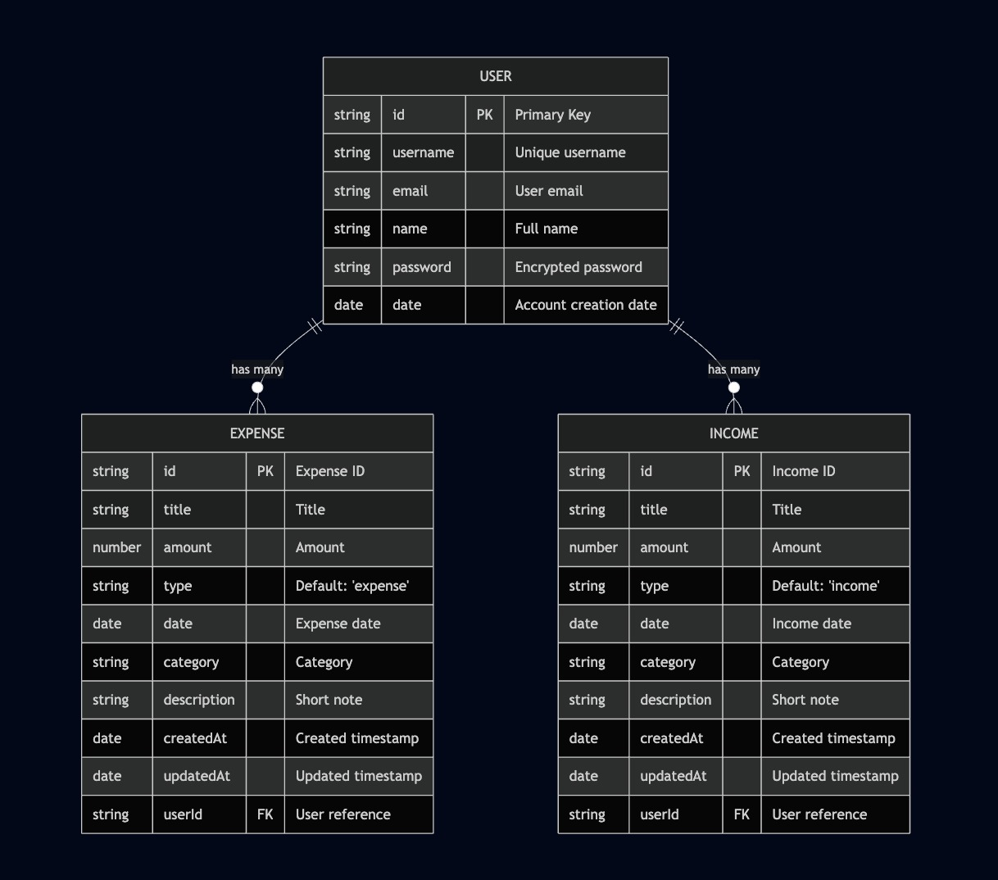

**User Stories**

| **User Type** | **Functional Requirement (Epic)** | **User Story Number** | **User Story / Task** | **Acceptance criteria** | **Priority** | **Release** |
| --- | --- | --- | --- | --- | --- | --- |
| Customer (Mobile user) | Registration | USN-1 | As a user, I can register for the application by entering my email, password, and confirming my password. | I can access my account / dashboard | High | Sprint-1 |
|  | Registration | USN-2 | As a user, I will receive confirmation email once I have registered for the application. | I can receive confirmation email & click confirm | High | Sprint-1 |
|  | Registration | USN-3 | As a user, I can register for the application through Facebook. | I can register & access the dashboard with Facebook Login | Low | Sprint-2 |
|  | Registration | USN-4 | As a user, I can register for the application through Gmail. | I can register & access the dashboard with Gmail Login | Medium | Sprint-1 |
|  | Login | USN-5 | As a user, I can log into the application by entering email & password. | I can access my account / dashboard | High | Sprint-1 |
|  | Dashboard | USN-6 | As a user, I can view my total income, expenses, and balance on the dashboard. | I see updated financial summary on dashboard | High | Sprint-1 |
|  | Transaction Management | USN-7 | As a user, I can add, edit, or delete income and expense transactions. | I can manage transactions and see them reflected instantly | High | Sprint-2 |
|  | Analytics | USN-8 | As a user, I can view charts showing my spending by category and over time. | I see interactive charts on my dashboard | Medium | Sprint-2 |
|  | Search & Filter | USN-9 | As a user, I can search and filter transactions by date, category, or amount. | I can find specific transactions easily | Medium | Sprint-2 |
| Customer (Web user) | Registration/Login | USN-10 | As a user, I can register and log in from the web interface. | I can access my account from any browser | High | Sprint-1 |
|  | Dashboard | USN-11 | As a user, I can view my financial summary and recent transactions on the web. | I see my dashboard and recent activity | High | Sprint-1 |
|  | Transaction Management | USN-12 | As a user, I can manage my transactions from the web dashboard. | I can add, edit, and delete transactions | High | Sprint-2 |
|  | Analytics | USN-13 | As a user, I can view financial charts and summaries on the web. | I see interactive analytics on the dashboard | Medium | Sprint-2 |
| Administrator | User Management | USN-14 | As an admin, I can view and manage user accounts. | I can see a list of users and their activity | Low | Sprint-3 |
|  | System Monitoring | USN-15 | As an admin, I can monitor system health and usage statistics. | I can access system reports and logs | Low | Sprint-3 |